Introducing the PeWiBo Performers
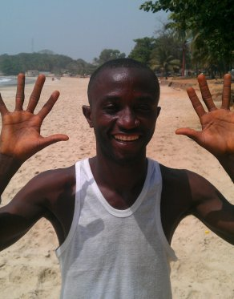 | Brima is a talented hoola-hooper, tray spinner and juggler and is our main workshop leader. He also dances, plays drums and makes shoes. He learnt circus skills on the streets of Freetown but at the age of 14 was taken in by the Don Bosco Fambul [http://www.donboscofambul.org] - a Catholic institution that works to reintegrate street children with family and schooling. In return, for the last 8 years he has been teaching circus skills at Don Bosco 3 times a week for free and has seen (and experienced first-hand) the transforming power of applying oneself to a performance project.

Morlai’s family comes from Port Loco in the north but moved to Freetown when he was 7 years old. His mother is a trader and his father is a retired dancer in the National Dance Troupe. Morlai’s schooling was terminated early due to lack of funds and so he became a dancer with the Cultural Village performance troupe. At the age of 28 he hopes to one day be able to afford to get back into adult education. He now lives in the Cultural Village in the Aberdeen District of Freetown and is a professional performer. | 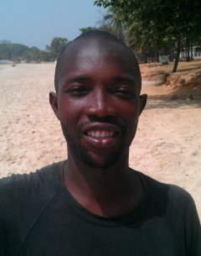

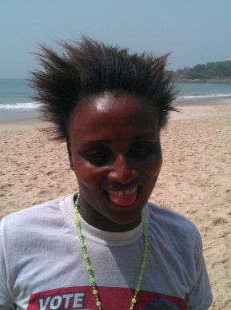 | Mummy’s family is from the Mandingo Tribe in the north, but she was born in Freetown. Her Grandfather used to be a dancer and would perform the Max Devil called the Witch Baird. She has always loved dancing from a very early age and when the money ran out for her schooling she took it up as a profession. She lives in the Cultural Village and enjoys learning poi and staff and dancing with fire fingers.

Sam was born in Freetown. His father is from Guinea and his mother is from the northern Kambia district of Sierra Leone. After the death of his parents he couldn’t pay for his schooling so he learnt to be a dancer. He also does acrobatics, contortion and fire performances. He is currently learning poi and staff and working on new ways to introduce fire into his acrobatics routines. He is also a talented drummer. | 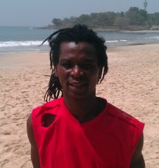

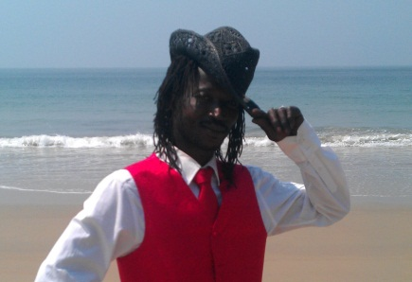 | Yokie is the stilts expert of the troupe and he can do the splits and get back up again!! He was born in Freetown but his father lives in Bo. He has 3 boys called Emanuel (14), Edward (9) and Joseph (4). He missed out on school because of the civil war and so became a performer instead. He is also a good cobbler (i.e. he makes shoes).

Tessah is the youngest in the troupe and takes after her father who was also a dancer and is from Guinea. She was born in Freetown and her mother is from Lungi and part of the Susu tribe. She has always danced since she was very small and enjoys learning new routines. She lives in the Cultural Village in the Aberdeen area of Freetown and is also learning how to spin poi and dance with fire fingers. | 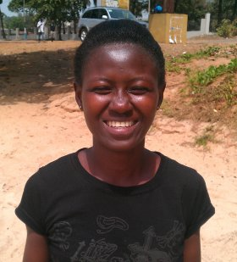

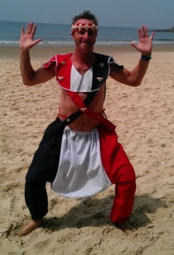 | Peachi-Pete is an experienced circus skills artiste and event organiser from the UK. He will be based in Freetown for a few years with his partner, who works for an INGO. Peachi was born in Segbwema in eastern Sierra Leone and is looking forward to visiting his birthplace. He aims to start up PeWiBo and then hand it over to his new (and much more talented) performance friends in Freetown. He is currently teaching the troupe poi and staff and how to run a workshop, and is setting up the admin and promo side of PeWiBo.

