An introduction to Salone Max Devils

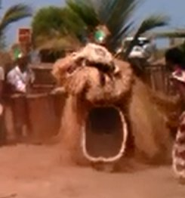 | Gaboi Devil – is from the Mende tribe in the south. It is the devil of a secret society that is used to crown a new paramount chief. It also comes out for the funeral of the chief. Only at these prestigious ceremonies can the Gabo Devil be seen as it leads the new chief to their office or help them into the next realm.

Nafali Devil – is the messenger for the same secret society as the Gaboi. The Nafali is sent for if you need to spread the word that a new paramount chief is to be crowned. | 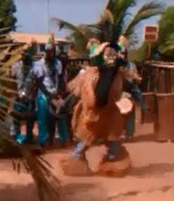

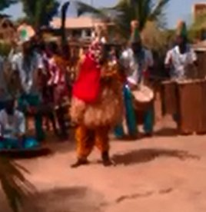 | Matuma Devil – is a Limba society devil from the Bangbani. He yields a machete and sports leopard print clothes. When the society goes out with the Matuma, and the Matuma sits down, then everyone must also sit down. If you don’t sit down quickly enough the devil calls bad things to happen to anyone left standing up.

Gongoli Devil – Is a fun devil from the Mende tribe in the south, who you should call when you are sad. It usually acts in a comedic way so that you feel happy and forget about your past. The Gongoli is always there for the small children to make them happy. | 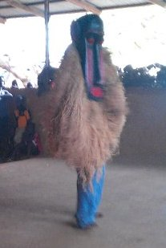

Photo to follow soon. | Witch Baird Devil – from the Timini tribe the Witch Baird is an enormous intricately decorated magical bird. This bird is used to conduct witchcraft. Once an old man brought it into the world to show the people that this is they use to do witch craft with. If you are lucky the Witch Baird will lay an ornate egg before your very eyes.

